*Florida International University*

*School of Computing and Information Sciences*

Software Engineering Focus

Feature Document

User Story ID: #739 Begin To Implement – A Machine Learning Algorithm from Resulting Data

**Name:** Filip Klepsa

**Team Member(s):** Lukas Borges, Cristian Cabrera, Hamilton Chevez, Nicolette Celli, Francico Lozada

**Project:** AR-VR-VE for Computer Science (Multimodal Interaction with ASL use case)

**Product Owner(s)**: Francisco Ortega

**Mentor(s)**: Francisco Ortega

**Instructor**: Francisco Ortega, Masoud Sadjadi

**User Story Name: 739 Begin To Implement – A Machine Learning Algorithm from Resulting Data**

Description:

* As a developer, I want to use the data collected from user story #727 to select the appropriate machine learning algorithm so that I can begin to implement the real-time gesture recognition feature.

Acceptance Criteria:

* Begin to design the structure of the MLA selected.
* Design the architecture that will pass recorded vector data to the MLA subsystem for processing.
* Determine if recorded data set is sufficient.

**Use Case**: **TEST Interpretation Recognition**

**Participating Actor:**

* User

**Entry Condition:**

* Actor must have application running and Leap Motion controller plugged in.
* Actor must have recorded gestures and converted the vector data to an angle.
* Actor must have hit TEST button on training form.
* Actor must have hit TEST button test form.

**Exit Condition:**

* The capture is completed, the file is stored in the Build/TestData directory.
* The actor is notified that the capture has completed and is given the option to recapture a new gesture to test.
* Test Data list is updated.

|  |  |
| --- | --- |
| **Actor Steps** | **System Steps** |
| 1. The actor hit test button and moves their hand in front of the Leap Motion Device Field of View. |  |
|  | 2. The system activates the Leap Motion Device and begins to poll vector data. |
| 3. The actor performs a gesture and hits the capture button. |  |
|  | 4. The system captures the physical gestures and saves it in the Build/TestData directory beginning at index 0 and provides the actor the ability to recapture. |
|  | 5. The system compares vector data between the captured test and all recorded frames in the program library, then outputs hit-rate of all tested gestures. |
| 6. The actor can choose to recapture a new gesture frame. |  |

**Use Case Diagram**

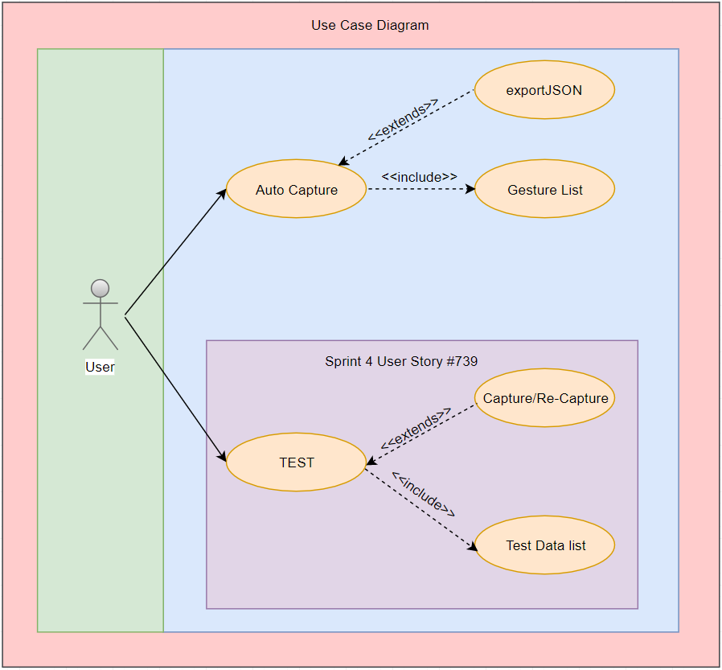

**Sequence Diagram**

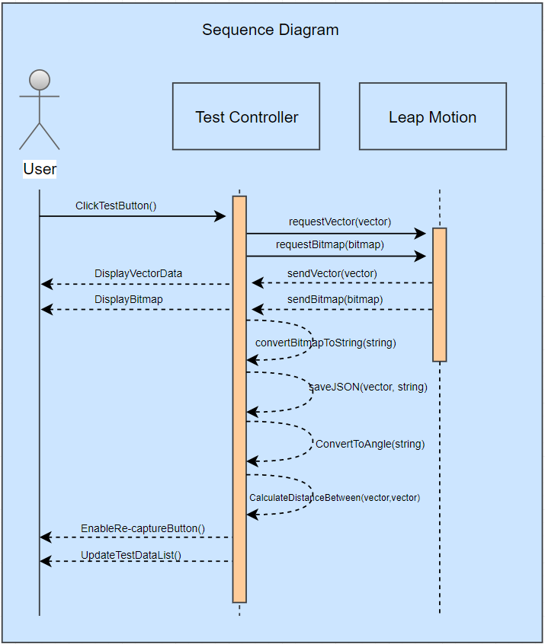

**Class Diagram**

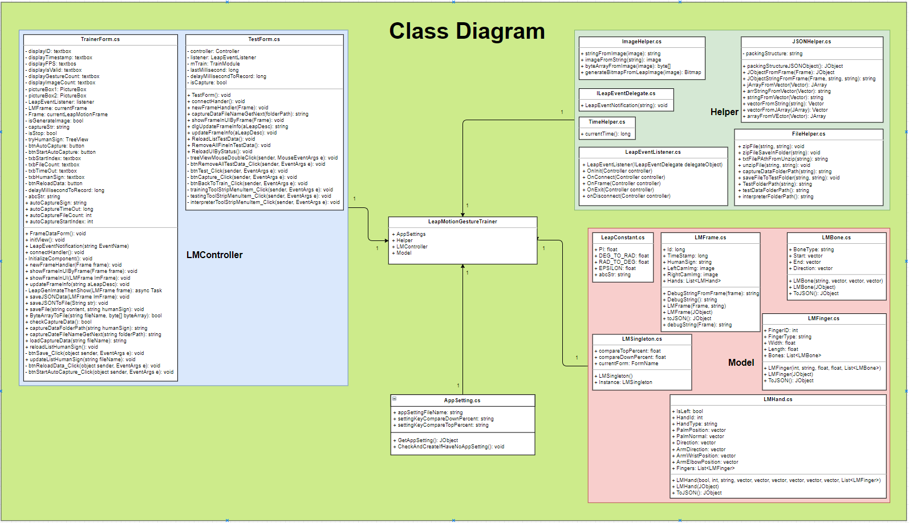

**Unit Test** -Coming Soon

* Test case ID:
* Description/Summary of Test:
* Pre-condition:
* Expected Results:
* Actual Result:
* Status (Fail/Pass):

**Integration Test**

**Visual User Guide**

